Manage Microsoft Entra ID Identities

Lab Overview
This lab focuses on user and group management in Microsoft Entra ID. You will create internal and guest users, then organize them into security groups.
Estimated Time: 30 minutes
Azure Region Used: East US (can be changed)
Prerequisite: Active Azure subscription

Lab Scenario
Your organization is preparing a pre-production lab environment. New engineers must authenticate using Microsoft Entra ID.
Your responsibility is to:
- Create users
- Invite external users
- Create groups
- Assign group members

Architecture diagram

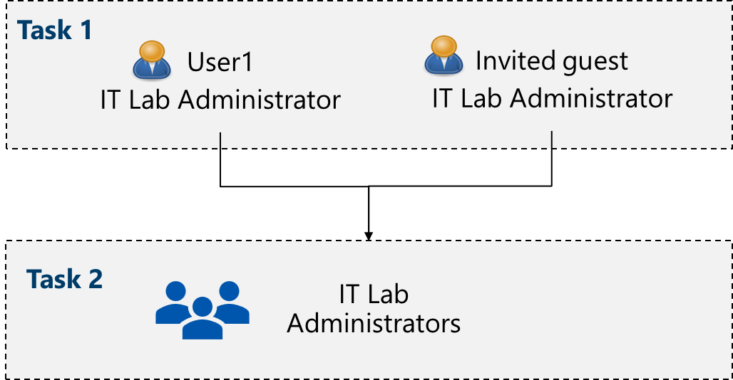

Task 1 – Create and Configure User Accounts

Step 1: Open Microsoft Entra ID
- Sign in to https://portal.azure.com
- Search for Microsoft Entra ID
- Review the Overview page
- Understand the tenant concept
Note:
A tenant is a dedicated Microsoft Entra ID instance that holds users, groups, and settings for an organization.

Step 2: Create an Internal User
- Go to Microsoft Entra ID → Users
- Select New user → Create new user
- Enter the following details:
Setting | Value
User principal name | az104-user1
Display name | az104-user1
Password | Auto-generate
Account enabled | Yes
Job title | IT Lab Administrator
Department | IT
Usage location | United States
- Select Review + create → Create
- Refresh and verify the user is created

Step 3: Invite an External (Guest) User
- Go to Users → New user → Invite an external user
- Enter the following:
Setting | Value
Email | Your personal email
Display name | Your name
Invite message | Welcome to Azure and our group project
Job title | IT Lab Administrator
Department | IT
Usage location | United States
- Select Review + invite → Invite
- Confirm the guest user appears in the Users list
- Check your email for the invitation

Task 2 – Create Groups and Add Members

Step 1: Open Groups
- Go to Microsoft Entra ID → Groups
- Review group settings:
  - Expiration – Group lifetime
  - Naming policy – Prefix/suffix rules

Step 2: Create a Security Group
- Select + New group
- Enter the following details:
Setting | Value
Group type | Security
Group name | IT Lab Administrators
Description | Administrators that manage the IT lab
Membership type | Assigned
Note:
Dynamic membership requires Entra ID Premium P1 or P2.

Step 3: Assign Owner and Members
- Select No owners selected
  - Add yourself as the owner
- Select No members selected
  - Add:
    - az104-user1
    - Invited guest user
- Select Create
- Refresh and verify group creation
- Open the group and review Members and Owners

